Load IAR
An IAR is an Inventory Archive - all inventory, or an object, image, mesh, or a folder. You click the Menu to load a Free IAR from the Outworldz, and a list of free IARs appears:
The name, file size, and the credits/license for the IAR appears when you hover your mouse over the photo.
You can search for an IAR.
There is NO PASSWORD used in DreamGrid IARS. Grid Owners are responsible for the contents of the Grid and should be able to backup individual IARS on request.
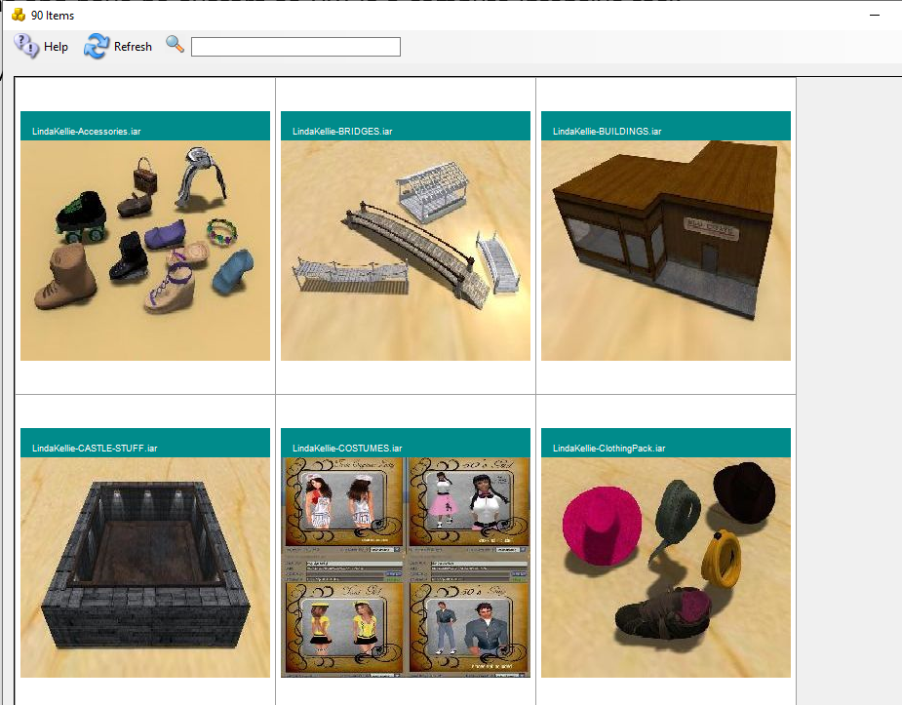

After clicking a desired Item, the system will show an avatar First and Last Name box.
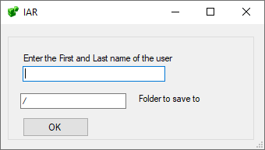
The default is "/", but you can load your IAR to the Inventory with "/Objects", or to a specific folder, such as /Textures. The folder must already exist.
The inventory will load in one of the Dos boxes.
You may need to re-login to see your new inventory item.

Bulk Load IARs
You can load a whole folder of IARs into one avatar’s inventory in one step.
- Click Content, then Bulk Load IARs.
- Pick the folder that holds your IAR files. IARs in folders inside it are loaded too.
- Type the avatar’s First and Last Name, and the inventory folder to load into. Leave the folder as "/" to load into the top of the inventory.
- Click OK to start.
DreamGrid loads the IARs one at a time, in name order. The log shows how many were queued. A large folder can take a long time.
Every IAR goes into the same inventory folder. The folder must already exist. The folders inside each IAR are kept.
Your grid must be running, and the Welcome region must be up. If not, nothing is loaded.
CAUTION: Bulk loading the same folder twice loads every item twice.

Links:
http://opensimulator.org/wiki/Inventory_Archives

